# Team RSA Midpoint Report

Project Objective: Analyze congestion and incidents on Weekends for three highways (I-84 West, I-205 North, US-26 East) during a time span of seven years (2012-2018).

Progress: We have created our first heatmap visualization, showing congestion data from Saturdays in May 2018 on I-84 West:

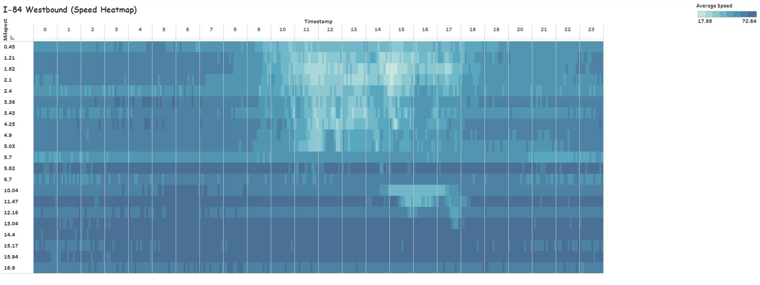

We have compiled all of the necessary data to create the remaining heatmaps: Congestion data at a 5 minute interval for Saturdays and Sundays from 2012 to 2018 on I-84W, I-205N, and US-26E is in our database.

Milestones Completed:

1. Traffic data collection and creation of tables
2. Heatmap generation for one highway (One month data)
3. Come up with a methodology to generate heat maps and plot incidents for any given highway across any time period

To be completed:

1. Mapping incidents on I-84 West
2. Generate heatmaps and plot incidents for 7 years
3. Analyze the graphs and note important patterns/observations.

Modifications:

If plotting incident data to specific highways isn’t feasible, we will simply generate a heatmap of incidents across all of the Portland area for Saturdays and Sundays between 2012 and 2018.